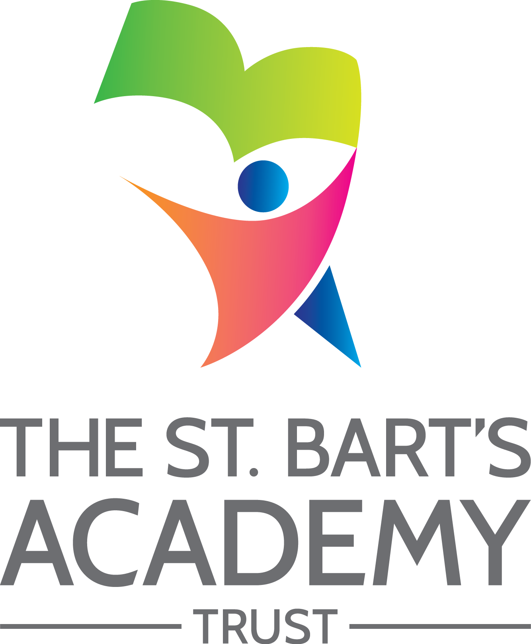

Privacy Notice
(For Parents)

September 2020

The St. Bart’s Academy Trust
Privacy Notice
Produced Date: |  | September 2020
Approved by Trust Board: |  | 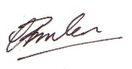 | Christopher Brislen  Chief Executive Officer
Review Date: |  | September 2022
Date | Section Amended |  |  | Signature

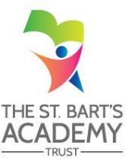

Contents

Privacy Notice (How we use pupil information) 4
The categories of pupil information that we collect, use, hold and share 4
Why we collect and use this information 4
The lawful basis on which we use this information 4
Collecting pupil information 5
Storing pupil data 5
Who we share pupil information with 5
Why we share pupil information 6
Data collection requirements 6
The National Pupil Database (NPD) 6
Requesting access to your personal data 7
Parents and pupils’ rights regarding personal data 7
Approach to managing SAR’s over school holidays. 8
Complaints 8
Contact 8

Privacy Notice (How we use pupil information)
Under data protection law, individuals have a right to be informed about how the school uses any personal data that we hold about them. We comply with this right by providing ‘privacy notices’ (sometimes called ‘fair processing notices’) to individuals where we are processing their personal data.

This privacy notice explains how we collect, store and use personal data about pupils.

The categories of pupil information that we collect, use, hold and share (when appropriate) includes, but is not restricted to:
- Personal information (such as name, unique pupil number, date of birth and address)
- Contact details, contact preferences, identification documents
- Characteristics (such as ethnicity, language, nationality, country of birth and free school meal eligibility)
- Attendance information (such as sessions attended, number of absences and absence reasons)
- Assessment information including internal assessment and externally set tests
- Curricular records
- Safeguarding information
- Details of any support received, including care packages, plans and support providers
- Medical information
- Special educational needs information
- Behavioural information
- Exclusion information
- Pupil Premium information
- Children in service families information
- Photographs
- CCTV images captured in school

We may also hold data about pupils that we have received from other organisations, including other schools, local authorities and the Department for Education.

Why we collect and use this information
We use the pupil data:

- to support pupil learning
- to monitor and report on pupil progress
- to provide appropriate pastoral care
- to protect pupil welfare
- to assess the quality of our services
- to administer admissions waiting lists
- to carry out research
- to comply with the law regarding data sharing

The lawful basis on which we use this information
We only collect and use pupils’ personal data when the law allows us to. Most commonly, we process it where:

- We need to comply with a legal obligation
- We need it to perform an official task in the public interest

Less commonly, we may also process pupils’ personal data in situations where:

- We have obtained consent to use it in a certain way
- We need to protect the individual’s vital interests (or someone else’s interests)

Where we have obtained consent to use pupils’ personal data, this consent can be withdrawn at any time. We will make this clear when we ask for consent, and explain how consent can be withdrawn.

Some of the reasons listed above for collecting and using pupils’ personal data overlap, and there may be several grounds which justify our use of this data.

Collecting pupil information
While the majority of information we collect about pupils is mandatory, there is some information that can be provided voluntarily.

Whenever we seek to collect information from you or your child, we make it clear whether providing it is mandatory or optional. If it is mandatory, we will explain the possible consequences of not complying.

Storing pupil data
We keep personal information about pupils while they are attending our school. We may also keep it beyond their attendance at our school if this is necessary in order to comply with our legal obligations. Our Records Management Policy sets out how long we keep information about pupils and is taken from the Information and Records Managements Society’s toolkit for schools.

Who we share pupil information with
We do not share information about pupils with any third party without consent unless the law and our policies allow us to do so

Where it is legally required, or necessary (and it complies with data protection law), we may share personal information about pupils with:

- the pupil’s family and representatives
- schools that the pupil’s attend after leaving us
- our local authority - to meet our legal obligations to share certain information with it, such as safeguarding concerns and exclusions
- the Department for Education (DfE)
- Ofsted
- The Multi-Academy Trust
- School Nurse and NHS
- Social Services
- Suppliers and service providers – to enable them to provide the service we have contracted them for
- Financial organisations and our auditors
- Central and local government
- Survey and research organisations
- Security organisations
- Professional advisers and consultants
- Charities and voluntary organisations
- Police forces, courts, tribunals
- Professional bodies

Where we transfer personal data to a country or territory outside the European Economic Area, we will do so in accordance with data protection law.

Why we share pupil information
We do not share information about our pupils with anyone without consent unless the law and our policies allow us to do so.

We share pupils’ data with the Department for Education (DfE) on a statutory basis. This data sharing underpins school funding and educational attainment policy and monitoring.

We are required to share information about our pupils with the (DfE) under regulation 5 of The Education (Information About Individual Pupils) (England) Regulations 2013.

Data collection requirements
To find out more about the data collection requirements placed on us by the Department for Education (for example; via the school census) go to https://www.gov.uk/education/data-collection-and-censuses-for-schools.

The National Pupil Database (NPD)
The NPD is owned and managed by the Department for Education and contains information about pupils in schools in England. It provides invaluable evidence on educational performance to inform independent research, as well as studies commissioned by the Department. It is held in electronic format for statistical purposes. This information is securely collected from a range of sources including schools, local authorities and awarding bodies.

We are required by law, to provide information about our pupils to the DfE as part of statutory data collections such as the school census and early years’ census. Some of this information is then stored in the NPD. The law that allows this is the Education (Information About Individual Pupils) (England) Regulations 2013.

To find out more about the NPD, go to https://www.gov.uk/government/publications/national-pupil-database-user-guide-and-supporting-information.

The department may share information about our pupils from the NPD with third parties who promote the education or well-being of children in England by:

- conducting research or analysis
- producing statistics
- providing information, advice or guidance

The Department has robust processes in place to ensure the confidentiality of our data is maintained and there are stringent controls in place regarding access and use of the data. Decisions on whether DfE releases data to third parties are subject to a strict approval process and based on a detailed assessment of:

- who is requesting the data
- the purpose for which it is required
- the level and sensitivity of data requested: and
- the arrangements in place to store and handle the data

To be granted access to pupil information, organisations must comply with strict terms and conditions covering the confidentiality and handling of the data, security arrangements and retention and use of the data.

For more information about the department’s data sharing process, please visit: https://www.gov.uk/data-protection-how-we-collect-and-share-research-data

For information about which organisations the department has provided pupil information, (and for which project), please visit the following website: https://www.gov.uk/government/publications/national-pupil-database-requests-received

To contact DfE: https://www.gov.uk/contact-dfe

Requesting access to your personal data
Under data protection legislation, parents and pupils have the right to request access to information about them that we hold. To make a request for your personal information, or be given access to your child’s educational record, contact the academy Compliance Officer in the first instance – details below.

You also have the right to:

- object to processing of personal data that is likely to cause, or is causing, damage or distress
- prevent processing for the purpose of direct marketing
- object to decisions being taken by automated means (by a computer or machine rather than a person)
- in certain circumstances, have inaccurate personal data rectified, blocked, erased or destroyed; and
- claim compensation for damages caused by a breach of the Data Protection regulations

If you have a concern about the way we are collecting or using your personal data, we request that you raise your concern with us in the first instance. Alternatively, you can contact the Information Commissioner’s Office at https://ico.org.uk/concerns/

Parents and pupils’ rights regarding personal data
Individuals have a right to make a ‘subject access request’ to gain access to personal information that the school holds about them.

Parents/carers can make a request with respect to their child’s data. Parents also have the right to make a subject access request with respect to any personal data the school holds about them.

If you make a subject access request, and if we do hold information about you or your child, we will:

- Give you a description of it
- Tell you why we are holding and processing it, and how long we will keep it for
- Explain where we got it from, if not from you or your child
- Tell you who it has been, or will be, shared with
- Let you know whether any automated decision-making is being applied to the data, and any consequences of this
- Give you a copy of the information in an intelligible form

Individuals also have the right for their personal information to be transmitted electronically to another organisation in certain circumstances.

If you would like to make a request please contact our data protection officer.

Approach to managing SAR’s over school holidays.
We are happy to help individuals to access their information in a timely manner, but may find it more difficult to respond during the summer holidays. Therefore although you are entitled to submit subject access requests all year round, please bear in mind that it may be necessary for us to extend the response period when requests are submitted over the summer holidays. This is in accordance with article 12(3) of the GDPR, and will be the case where the request is complex – for example, where we need multiple staff to collect the data.

Complaints
We take any complaints about our collection and use of personal information very seriously.
If you think that our collection or use of personal information is unfair, misleading or inappropriate, or have any other concern about our data processing, please raise this with us in the first instance.

To make a complaint, please contact our Academy Compliance Officer.

Alternatively, you can make a complaint to the Information Commissioner’s Office:

- Report a concern online at https://ico.org.uk/concerns/
- Call 0303 123 1113
- Or write to: Information Commissioner’s Office, Wycliffe House, Water Lane, Wilmslow, Cheshire, SK9 5AF

Contact
If you have any questions, concerns or would like more information about anything mentioned in this privacy notice, please contact our compliance officer in the first instance:

[setting to include details of their administrator / compliance officer]

Choose an item.
Academy Compliance Officer
Name:

Address:

Tel:
Email:

St. Bart’s Academy Trust Data Protection Officer:
Name: Steve Jones

Address: St Bart’s Multi-Academy Trust
Belgrave St Bartholomew’s Academy
Sussex Place
Stoke-On-Trent
Staffordshire
ST3 4TP

Tel: 01782 486350
Email: office@sbmat.org

St. Bart’s Multi-Academy Trust
c/o Belgrave St. Bartholomew’s Academy,
Sussex Place, Longton, Stoke-on-Trent, Staffordshire, ST3 4TP
www.sbmat.org T: 01782 235524 F: 01782 235525

